Mission: Partnering with staff and families to create a safe, healthy and inclusive learning environment
to provide an enjoyable and positive school experience.
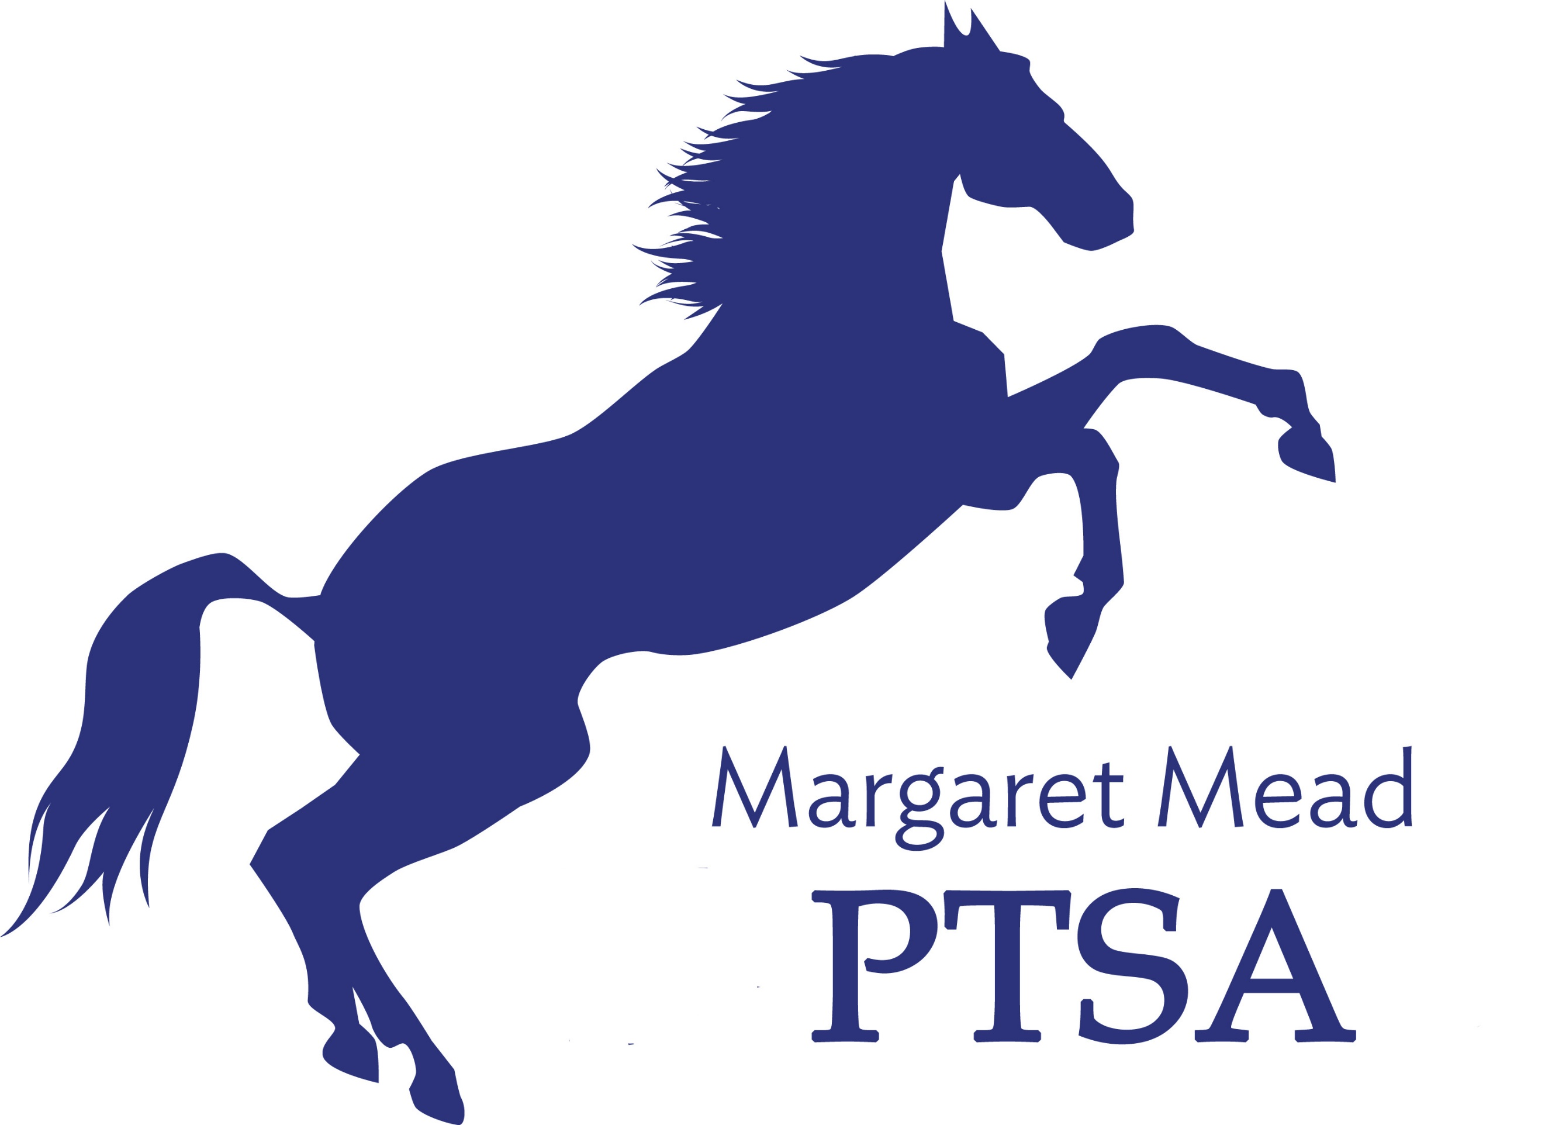
Margaret Mead Elementary PTSA
1725 216th AVE NE, Sammamish, WA 98074
PTSA Unit 2.8.38
www.meadptsa.org
Goals: Support the mission statement using:
effective communication, connecting community, financial support & fiscal responsibility.
Board of Directors Meeting - MINUTES
October 1, 2020
- Call to Order 7:36
Present: Sarah Jensen, Leta Hamilton, Sharon Wu, Molly Hylen, Ryika Hooshangi, Abi Nubla-Kung, Cassy Patterson, Sue Gabica, Heather Gibbons, Suzy Khendry, Sandy Klein, Liz Moore, Sharon Mason, Ashwini Godbole, Daniella Toledo, Trista Lofti, Ashley Harrington, Niko Olson
- Approval of the Minutes – Minutes for June BoD & September BoD moved into record.

- President’s Report: Ryika Hooshangi
- Word on the street – K-1 parents are preparing their students for a return to the building. As a board, it would be good to know which board members will have K-1 kids returning & which board members are choosing the Remote Academy. Covid Safety Plan is on the LWSD website.
- Shout out to Sharon Wu & Heather Gibbons. We are revamping our website. We are trying to update the Teacher Spotlight. Heather Gibbons has been posting fun things all week for Spirit Week.
- How can we create a “Yearbook” for this school year? Can we create a password protected page on our website with photos? Sharon Mason has a suggestion for someone who might be available to spearhead a Yearbook type “thing” for this year.
- Daniella Toledo is putting together a membership video. Spirit Week is wrapping up. Virtual “ice cream social” was a success. Communications received 33 photos of students eating their free ice cream to post on Facebook & put in our Mustang Report. We will have a pumpkin carving competition. We are collecting some prizes to give out for our community building events. Teachers will also have a pumpkin carving contest.
- New PTSA “How to…” series – We are starting a video series where staff members will share skills with the community. This includes all staff, including specialists & IAs.

- Vice President Report: Abi Nubla-Kung
- Moriah Oster is putting together our scholarship basket theme for this year. All submissions are experiences this year, not physical baskets. Our budget is $100
- Treasurer’s Report: Molly Hylen
- Not much new to report from August. $1400 came in September. Membership team is putting together a membership drive.
- Beginning balance for September was $94,905.73.
- Ending balance for September is $95,796.20
- 2019-2020 Mid-year Financial Audit went well. A copy of the audit is included with BoD meeting documents.
- Canceled Check –Date on check was April 30. Written on the check was “Void after 90 days.” Deposited on August 20. Check was returned & we were charged $12. Check was for $45. Molly has documentation for audit.
- Insurance Renewal – same coverage. No changes.
- New Grant Request – the grant is for 3 new tents. $650 approved for purchasing new tents.

- Committee Reports
FACE: Liz Moore & Trista Lotfi – No candy drive this year. Pumpkin carving contest is coming up. Glasshouse Dance studio has offered us a free Zoom dance class. Sharon Mason’s son’s TaeKwonDo studio will also do a free Zoom session.
Membership: This year we will hold a Virtual Membership Drive. Membership team is putting together a membership video to share with community. Current Membership numbers – 15% of school
Volunteer Coordinator: Ashwini Godbole shared that a Yoga class and Redmond Art Works are potential virtual events. For all volunteers with PTSA sponsored events Approved Volunteer status must be up to date.
Fundraising: Sharon Mason & Ashley Arrington shared that a Chipotle & MOD fundraising events are being set up now. Read-A-Thon fundraising event will be a big focus this year. More details to come. Amazon Smile is up & running. Some parents are clipping Box Tops & want to give them to school. Now Box Tops are virtual, but there are physical ones that are still valid & can be sent in for cash. Box Tops collection box can be put outside school. Pass The Hat has no suggested amount on website. Do we want one? We are going to suggest $50 per student. $25,000 goal. If we could get to $20.000, Molly Hylen would feel comfortable with our financial position for this year.
Communications: Heather Gibbons & Sharon Wu shared that we have a new secured Website. Migration to new web server is done. If you see anything wrong or an error message, let Sharon Wu know. She is working out the kinks. $120 per year is the fee for the new web site host. This year is free. If Sharon receives an invoice, send it to Molly. Heather Gibbons asked the board to send information to her for the Mustang Report & Facebook.
Sustainability: Suzy Khendry – nothing to report.
Emergency Prep: Antoinette Haynes & Cassy Patterson – LWSD Eprep meeting next week.
- Principal/Staff Update – staff working hard to prepare the building for eventual return to school.

- Adjourn: 8:55
Next Board Meeting—November 19, 2020 at 7:00pm

PTSA Board Meeting Dates
2020-2021

Thursday, September 3, 7pm
Thursday, October 1, 7:30pm*
Thursday, November 19, 7pm
Thursday, January 14, 7:30pm*
Thursday, February 4, 7pm
Thursday, March 11, 7pm
Thursday, April 15, 7pm
Thursday, May 20, 7:30pm*
Thursday, June 3, 7pm--Transition meeting

**Board Meetings will begin at 7pm, unless same night as general membership meeting

PTSA General Membership Meeting Dates

Thursday, October 1, 7pm
Thursday, January 14, 7pm
Thursday, May 20, 7pm

All meetings will be held virtually, until further notice

Tentative PTSA Calendar
- Sept.3: Board Meeting
- Sept. 25: First Math Challenge begins
- Sept. 28-Oct. 2: Spirit Week
- Oct. 1: Board Meeting and General Membership Meeting
- Oct. 23: Pumpkin decorating competition
- Nov. 19: Board Meeting
- Dec. 3: Talent Show Night*
- Dec. 16: Margaret Mead’s Birthday
- Dec. 17: Gingerbread House Decorating Competition*
- Jan. 14: Board Meeting and General Membership Meeting
- Jan 21: BINGO/Game Night
- Late Jan/Early Feb: Spelling Bee
- Feb. 4: Board Meeting
- March 4: International Night
- March 11: Board Meeting
- April 15: Board Meeting
- April 29: Virtual Cooking Class
- May 3-7: Teacher Appreciation Week
- May 20: Board Meeting and General Membership Meeting
- June 3: Board Meeting
- June 16: Last Day of School

**Spring Community Gathering (formerly Spring BBQ)---TBD
**Glow Dance Party—TBD
**Spring Social (formerly Dudes & Donuts)---TBD

